**Landing, Login, and Enrollment Pages Development**

Betina Driggers

The University of Arizona Global Campus

CST 499: Capstone for Computer Software Technology

Dr. Charmelia Butler

October 13, 2025

**Landing, Login, and Enrollment Pages Development**

This paper outlines the development of the landing (home), login, and registration features for an online course registration system implemented with PHP and MySQL on XAMPP. Using the provided project (“Online Course Registration”), I configured XAMPP to run PHP locally, created the database and tables, and built a reusable database connection class for queries. The login and registration flows were implemented with Bootstrap layouts, server-side input validation, PHP data objects–style behavior via mysqli prepared statements, and password hashing functions to protect sensitive data within the database. Screenshots of website pages, database, and source code are provided along with an explanation of design and implementation decisions. The thesis of this paper is that a minimal but secure PHP/MySQL stack using prepared statements and password_hash on XAMPP provides a reliable baseline for academic projects and can be extended to full course enrollment functionality with consistent session handling and filename health and cleanliness.

**Run PHP File in XAMPP**

Below are instructions regarding how to run a PHP file created in BBEdit using XAMPP on a MacBook Pro.

* Install and launch XAMPP using the XAMPP Control Panel.
* Ensure an application is not currently using port 80, and if one is, change the port XAMP will use for its servers to another port, such as 8080.
* In the “Manage Servers” tab, ensure all installed servers (including Apache Web Server) are successfully started and running.
* Open BBEdit from the Applications folder on the MacBook and create a new file.
* Write the PHP code needed.
* Save the file as “FileName.php” in the following directory /Applications/XAMP/htdocs. If a folder was created for the project, the path would be /Applications/XAMPP/htdocs/ProjectFolder/FileName.php.
* In an internet browser, navigate to: http://localhost:8080/ProjectFolder/FileName.php
* The code written in the PHP file will render the expected information, which will be displayed (XAMPP FAQs for Mac OS X, 2024).

**My SQL Database**

Database Creation:

In the Home tab of myPHPAdmin, I selected the "SQL" tab from the top navigation bar and provided the SQL command shown in the screenshot below to create the database. For easier readability, the command is: CREATE DATABASE course_registration; (W3Schools, 2019). This command initializes the central database used by all PHP scripts, ensuring a structured environment for managing users, courses, and enrollment data.

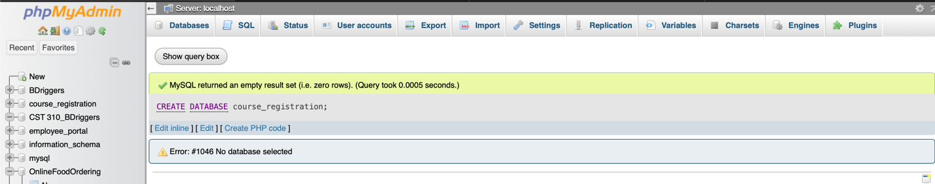

Database Table Creation:

After creating the database, I selected the "SQL" tab from the top navigation bar and provided the following SQL function, shown in the screenshot below, to ensure I have the correct database selected to create the table on. The function is: USE course_registration;. This function ensures the table is created on the desired database (W3Schools, n.d.).

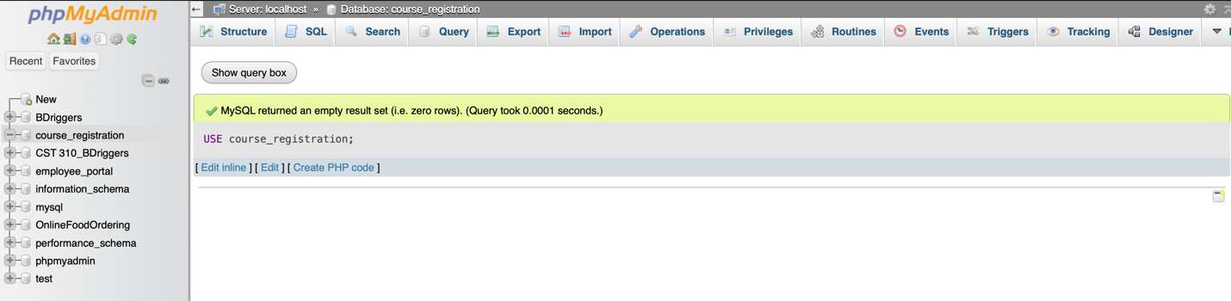

Once I selected the proper database, I then selected the "SQL" tab from the top navigation bar and provided the SQL statement below to create the table. The table supports user authentication and registration which ensures consistency using unique constraints on email and SSN.

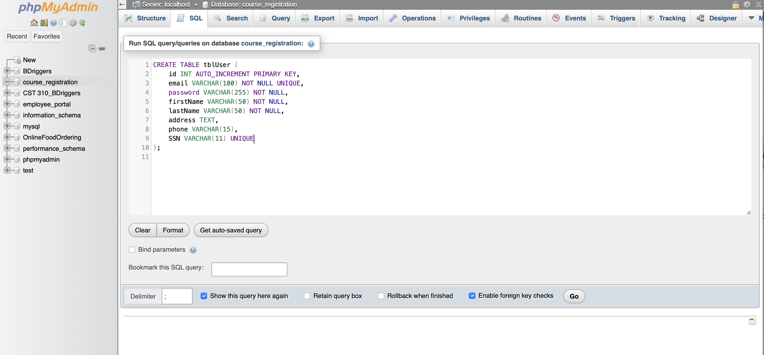

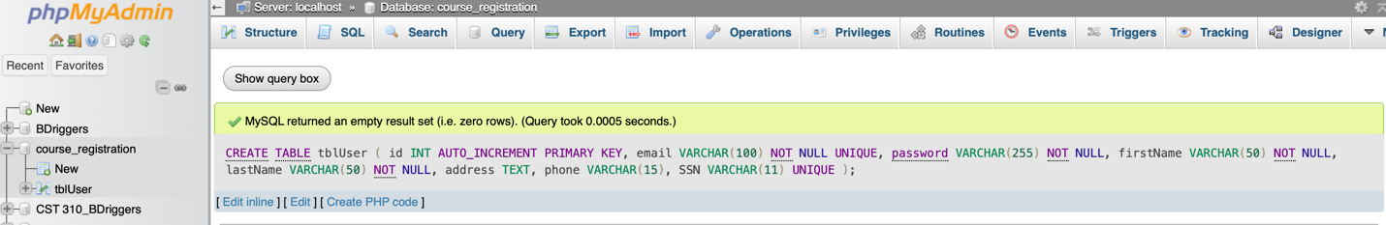

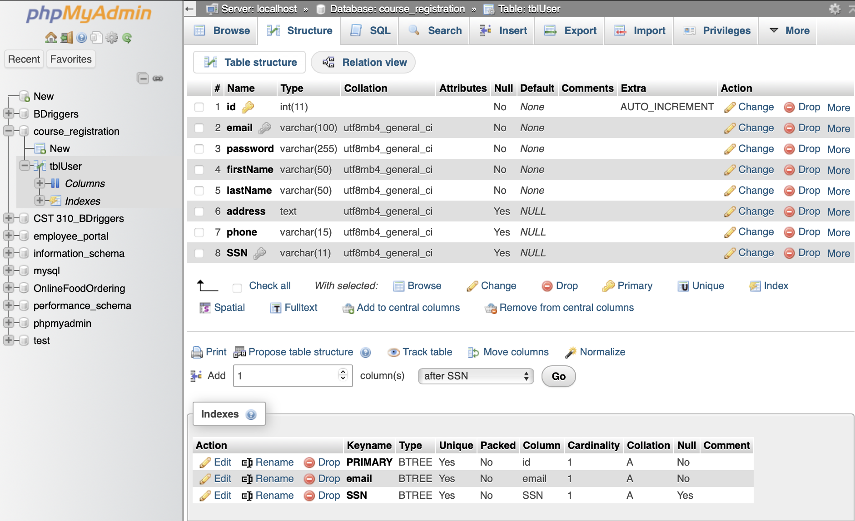

**Connection Class Creation**

When creating the class (CR_DB_Conn.php), I first established the code for the connection to the database via PHP code and incorporated a message that indicates if the connection to the database was successful or not. If the database connection was successful, I then listed out all databases. Additionally, I executed a SQL query within the class to insert a new row of data. A message is displayed indicating if the query was successfully executed or not, and displays the query that was executed.

Within the class code, I utilized several functions. However, the "executeQuery($con, $sql)" function was used when inserting the new rows of data into the table, as this query is responsible for running SQL queries that modify data. The "executeSelectQuery($con, $sql)" function was used when I instructed the class to display or show a list of databases located. This function is responsible for handling queries that retrieve data from the database.

Examples of other functions used within the connection class code were __construct() and closeConnection(). The construct function will handle creating the database connection, as that is an object I created from the class, and the closeConnection function is responsible for closing the database connection (PHP OOP Constructor, n.d.).

To enhance reliability, error handling was implemented to catch any connection or query failures using try/catch blocks in addition to the mysqli_report() function. This makes sure that if the connection or a query fails and an error occurs, the system will provide immediate feedback. This practice aligns with PHP object-oriented programming standards while promoting code that is not only secure but maintainable and scalable (PHP OOP Constructor, n.d.).

**CR_DB_Conn_Class**  
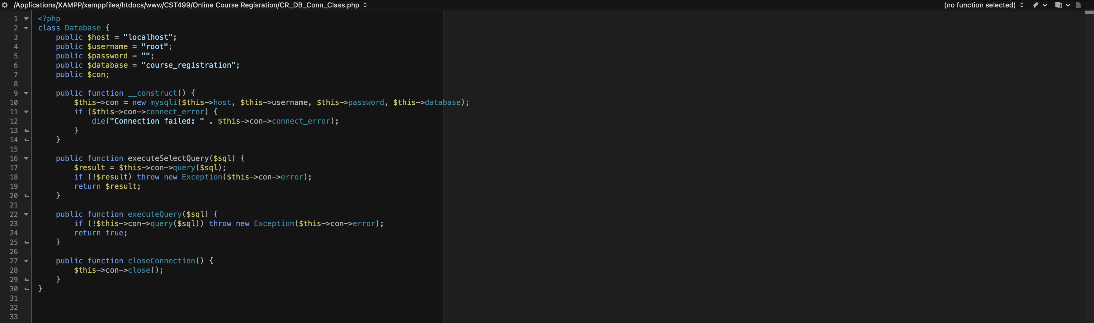

**Registration Page**

**Frontend: Registration Form Steps**

The frontend (user interface) is controlled by the Register.php code, which is a registration page created using HTML with Bootstrap for styling and responsiveness for a positive user experience (Bootstrap, n.d.). The form requires the user to enter their email address, first name, last name, address, phone number, and social security number (verify the information matches the student on file). The values for the phone number, and social security number, fields are automatically formatted as the user provides the information. If a field should only have numbers entered, the form only allows for numbers to be entered into those fields. These fields are phone number and social security number. Additionally, there is a notation indicating that fields with a red asterisk are required. Once the user clicks the “Login” button, the data provided by the user is securely passed to the Registration_Process.php code via POST (Bootstrap, n.d.).

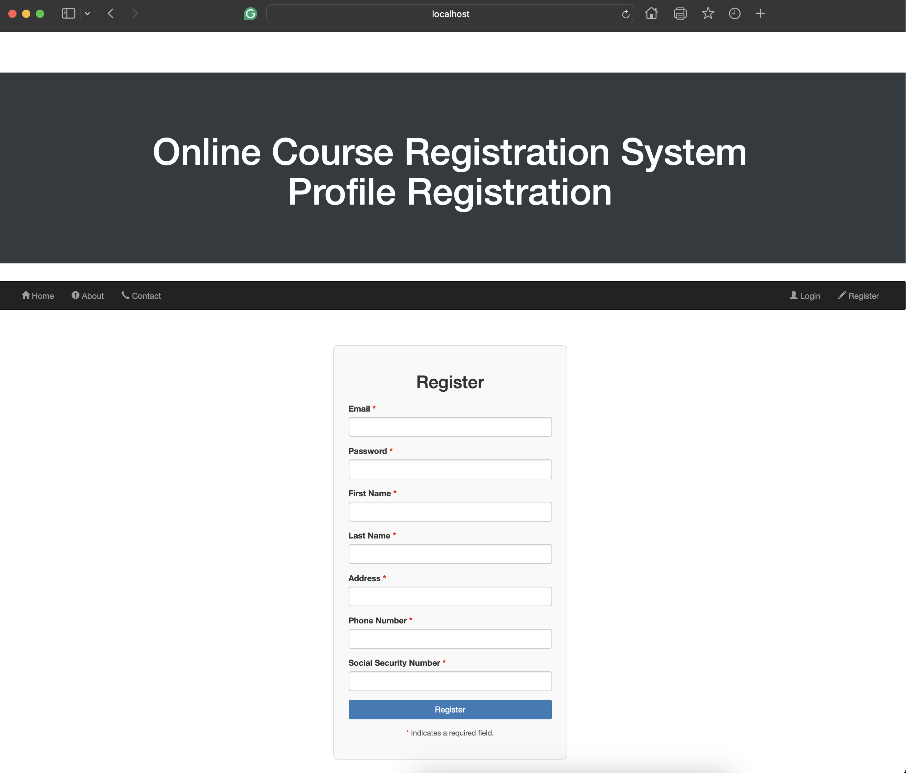

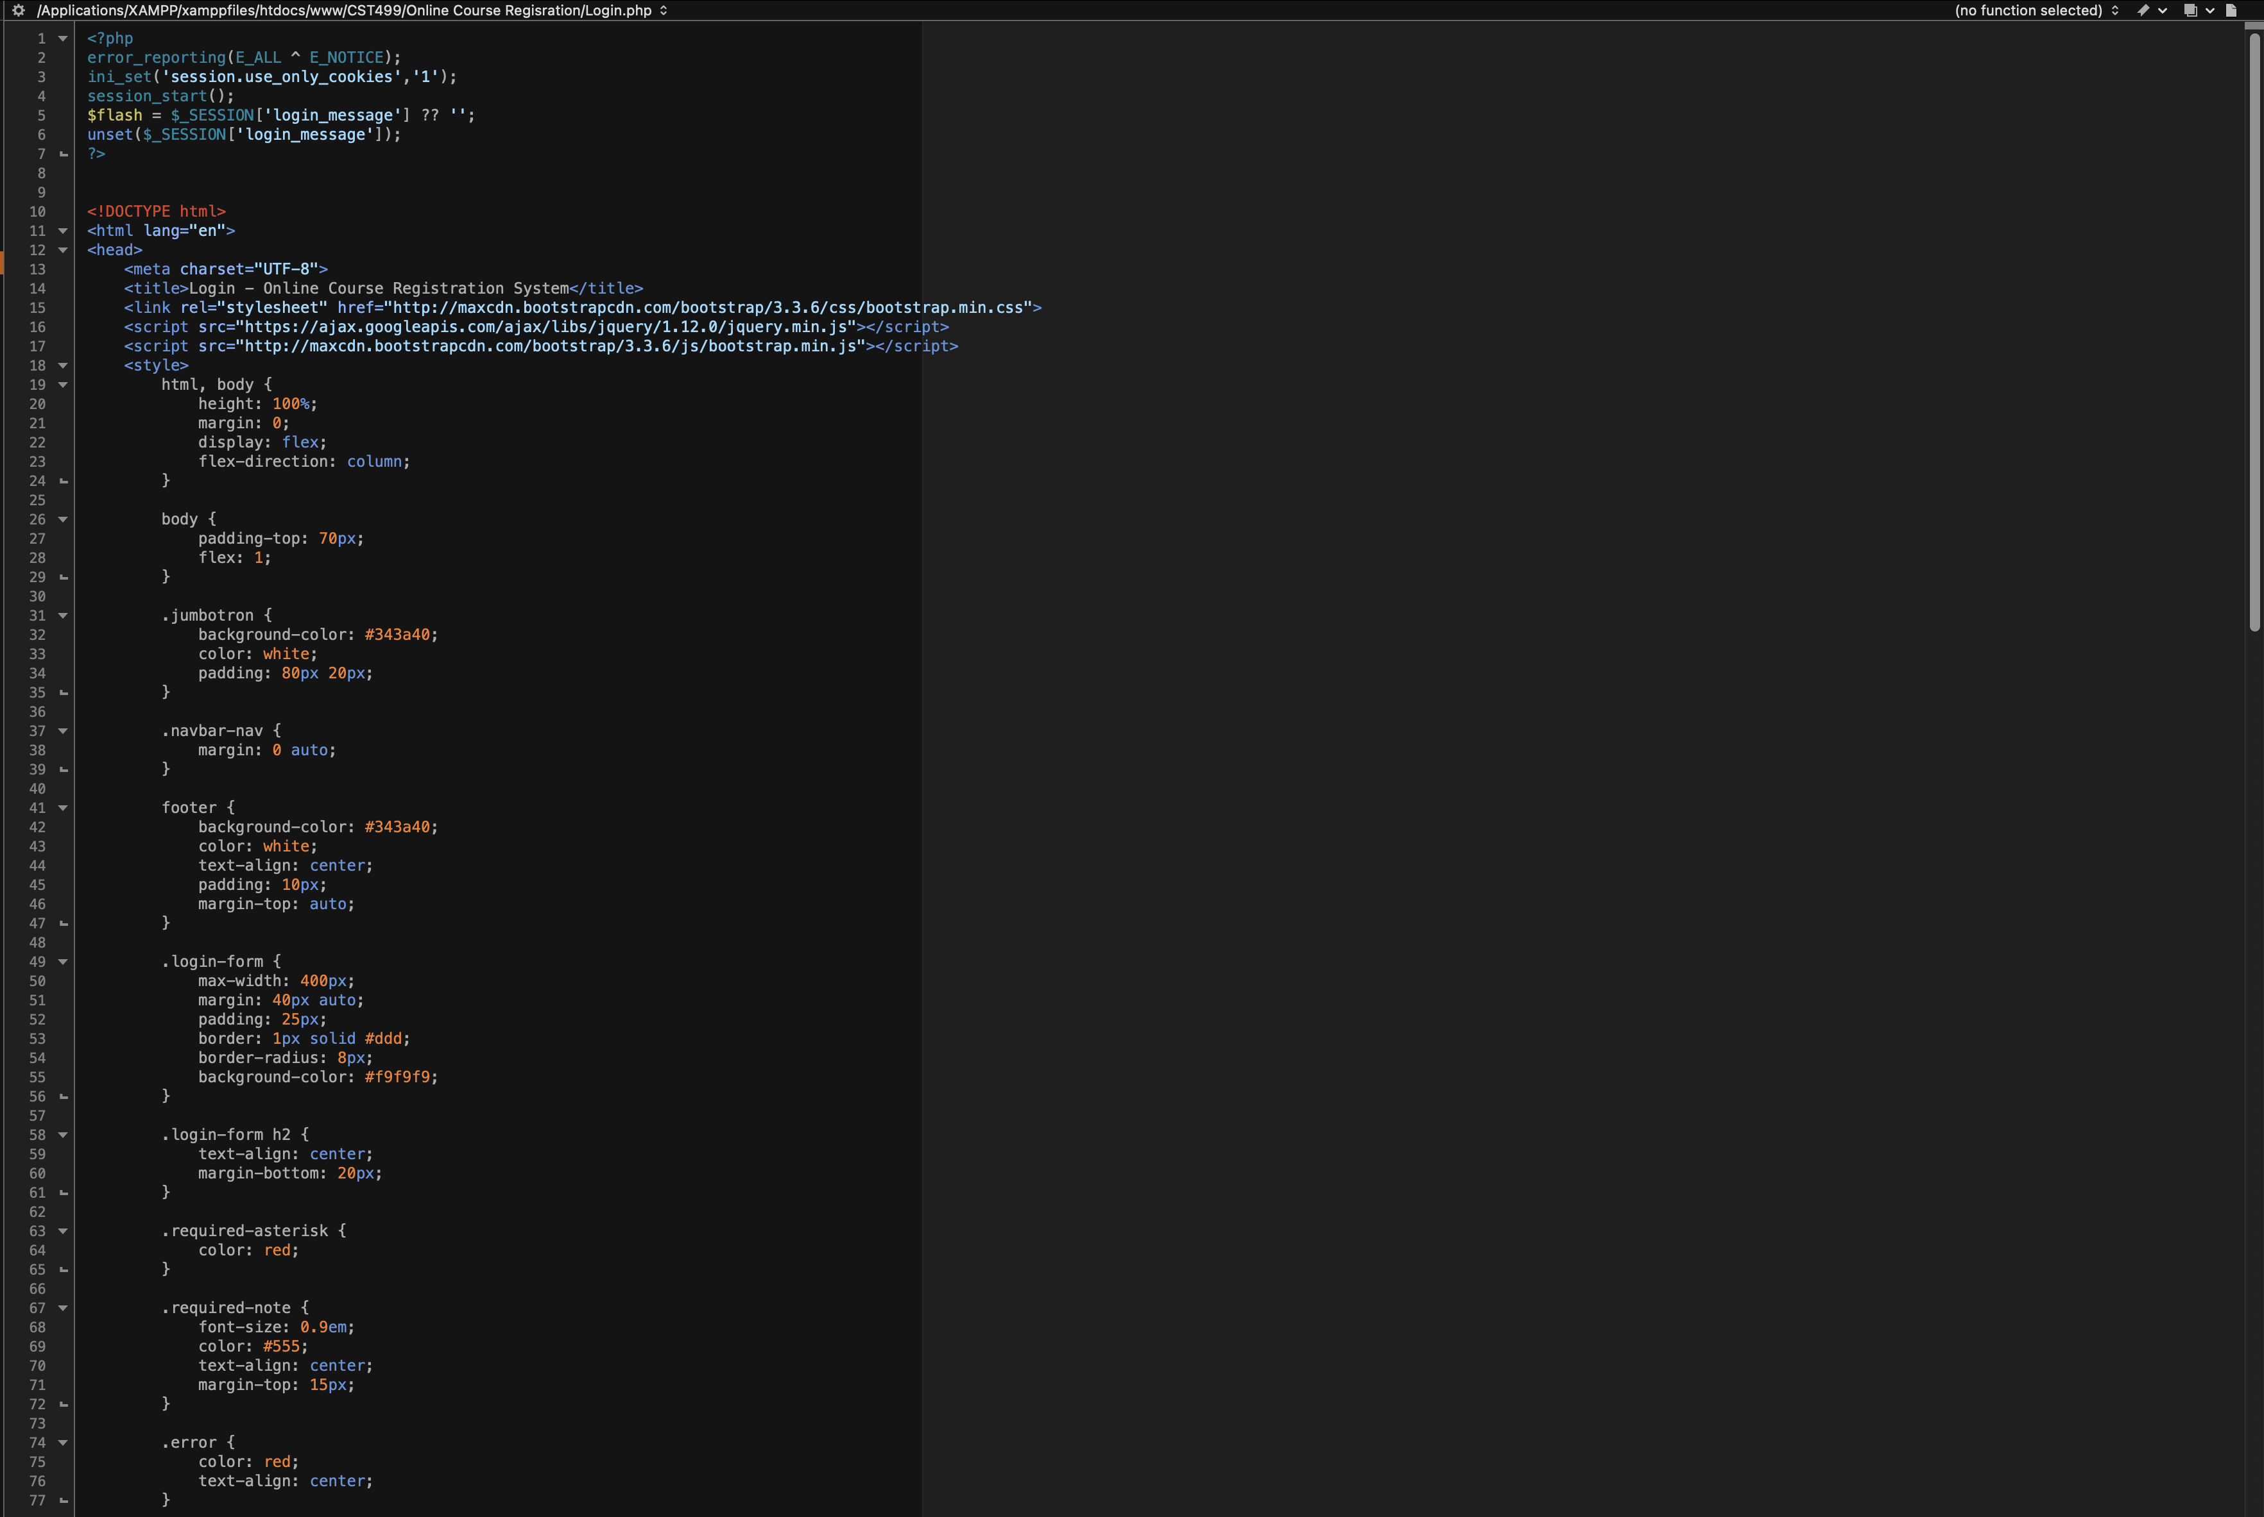

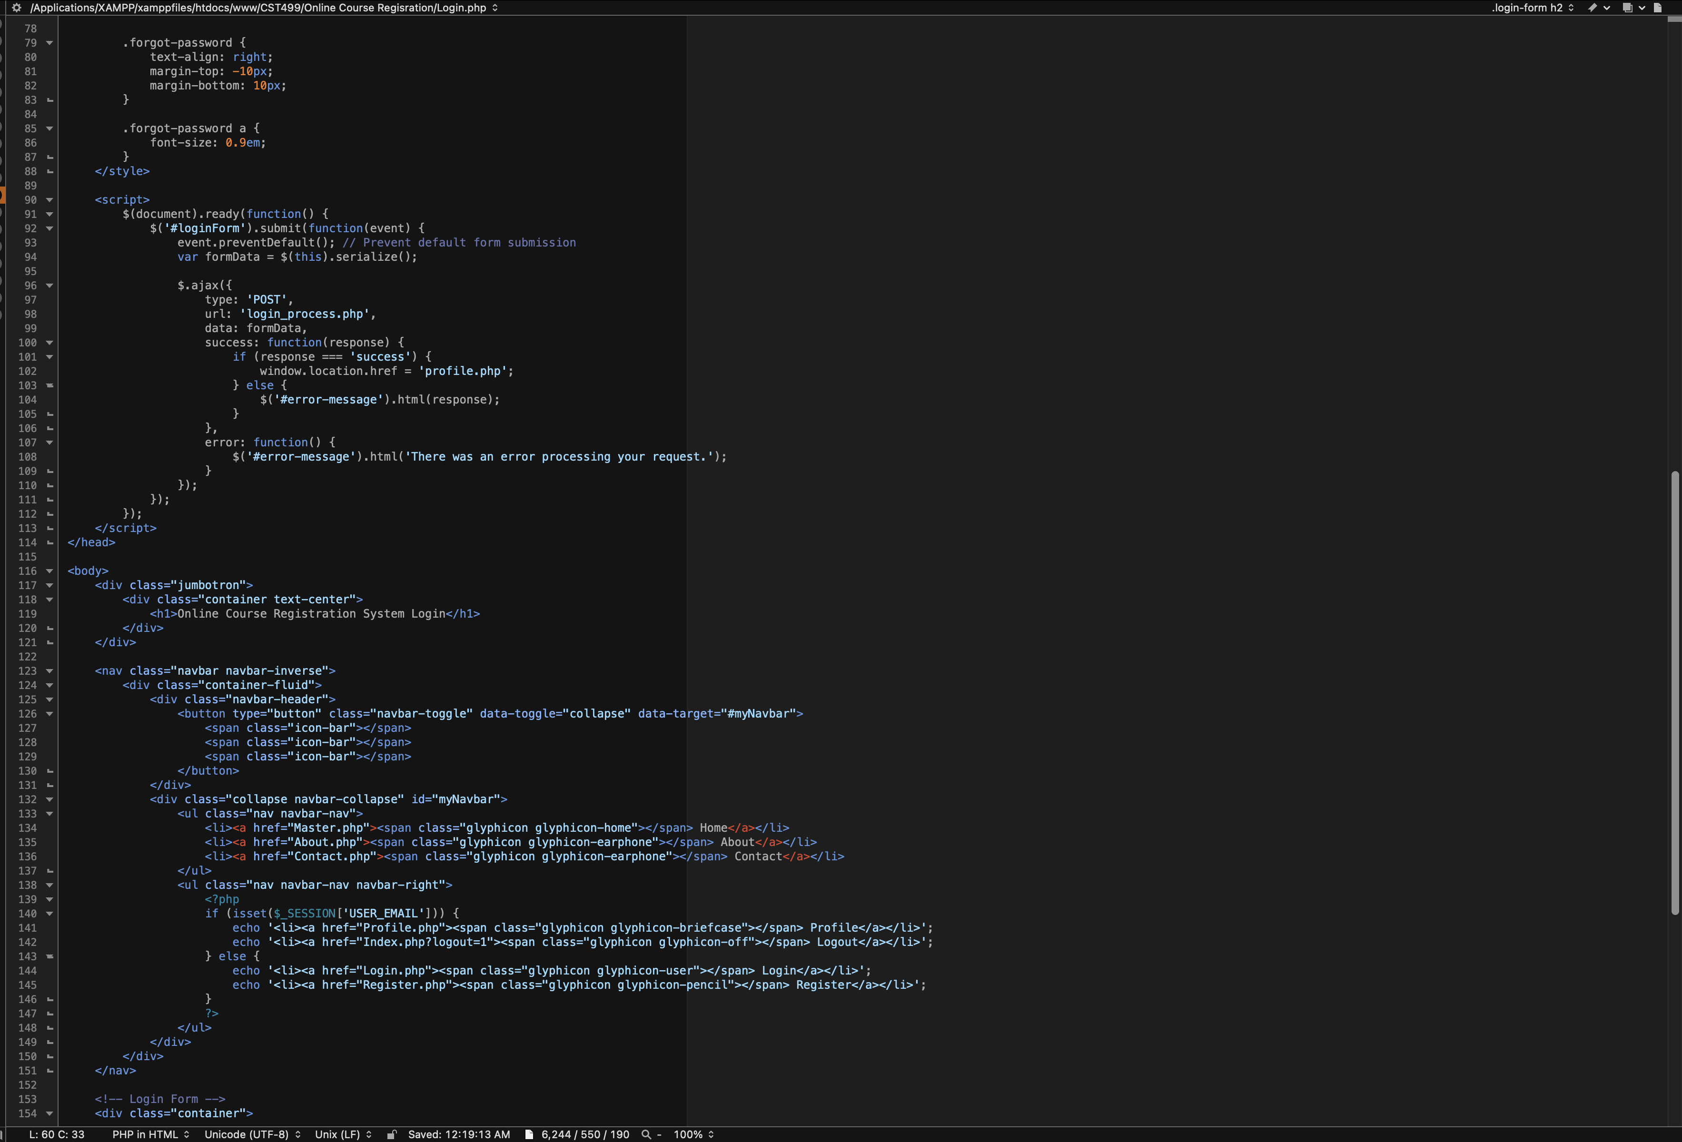

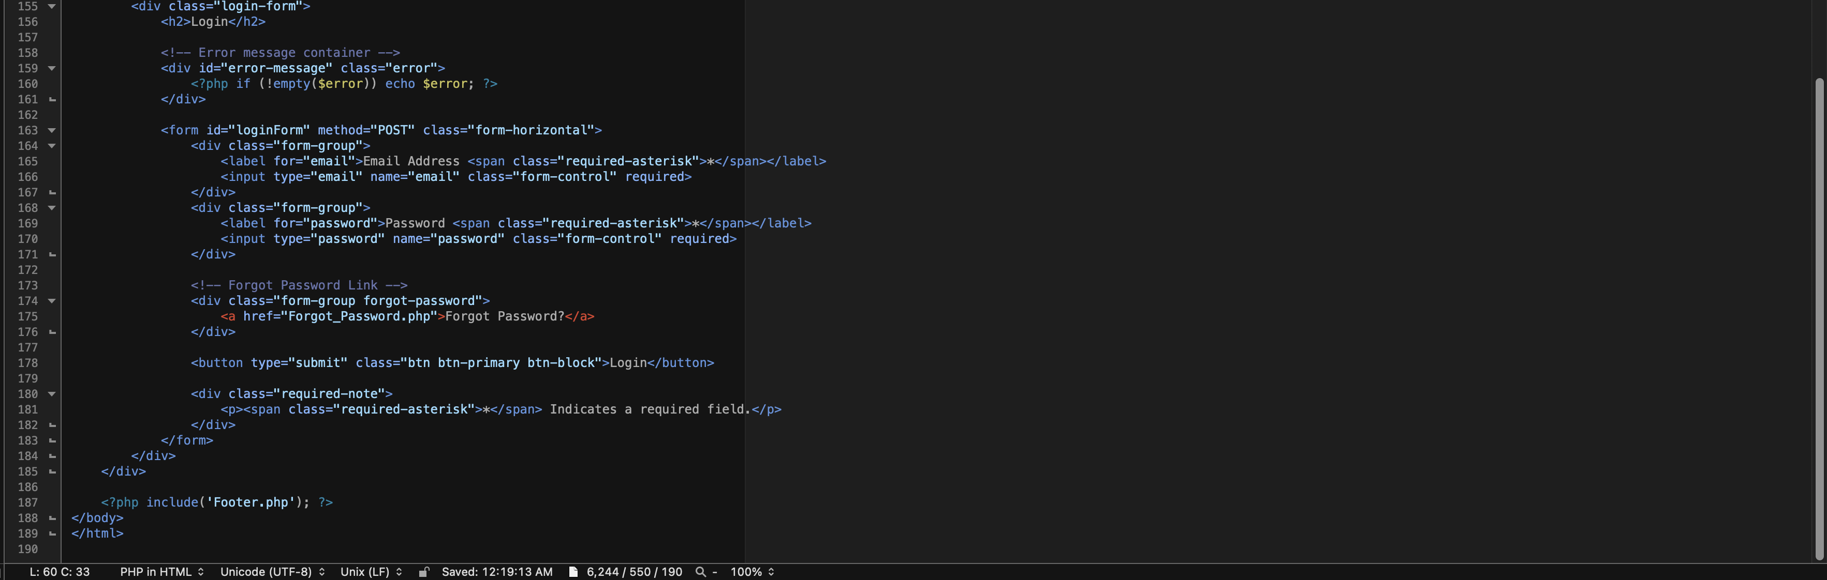

**Backend: Registration Processing Steps**

The backend is handled by the Registration_Process.php code and is responsible for submitting the information provided by the user in the form to the database. First, a database connection is established using the CR_DB_Conn_Class.php code, which is responsible for any SQL queries. Next, the Registration_Process.php code includes input validation by checking if the email address entered already exists in the database, and if so, providing the user with a pop-up indicating the email address already exists and then redirects the user to the Login page. If the email address does not exist, the password is hashed to ensure the password is securely stored in the database (PHP: Password Hashing - Manual, n.d.). The remaining fields are trimmed of any leading or ending whitespaces. When inserting a new user, the information provided by the user in the form is passed to and inserted into the tblUser table by using an included SQL statement. By providing the SQL statement within the backend, this helps reduce the chance of SQL injection. If the registration is successful, the user is redirected to the Login page to log into the Online Course Registration System, and if the registration is unsuccessful (excluding if the user has previously registered), an error message is presented indicating this, and the user is taken back to the registration form to attempt to register once more. This structured validation practice follows the best practices outlined in *Essentials of Software Engineering* (Tsui et al., 2018).

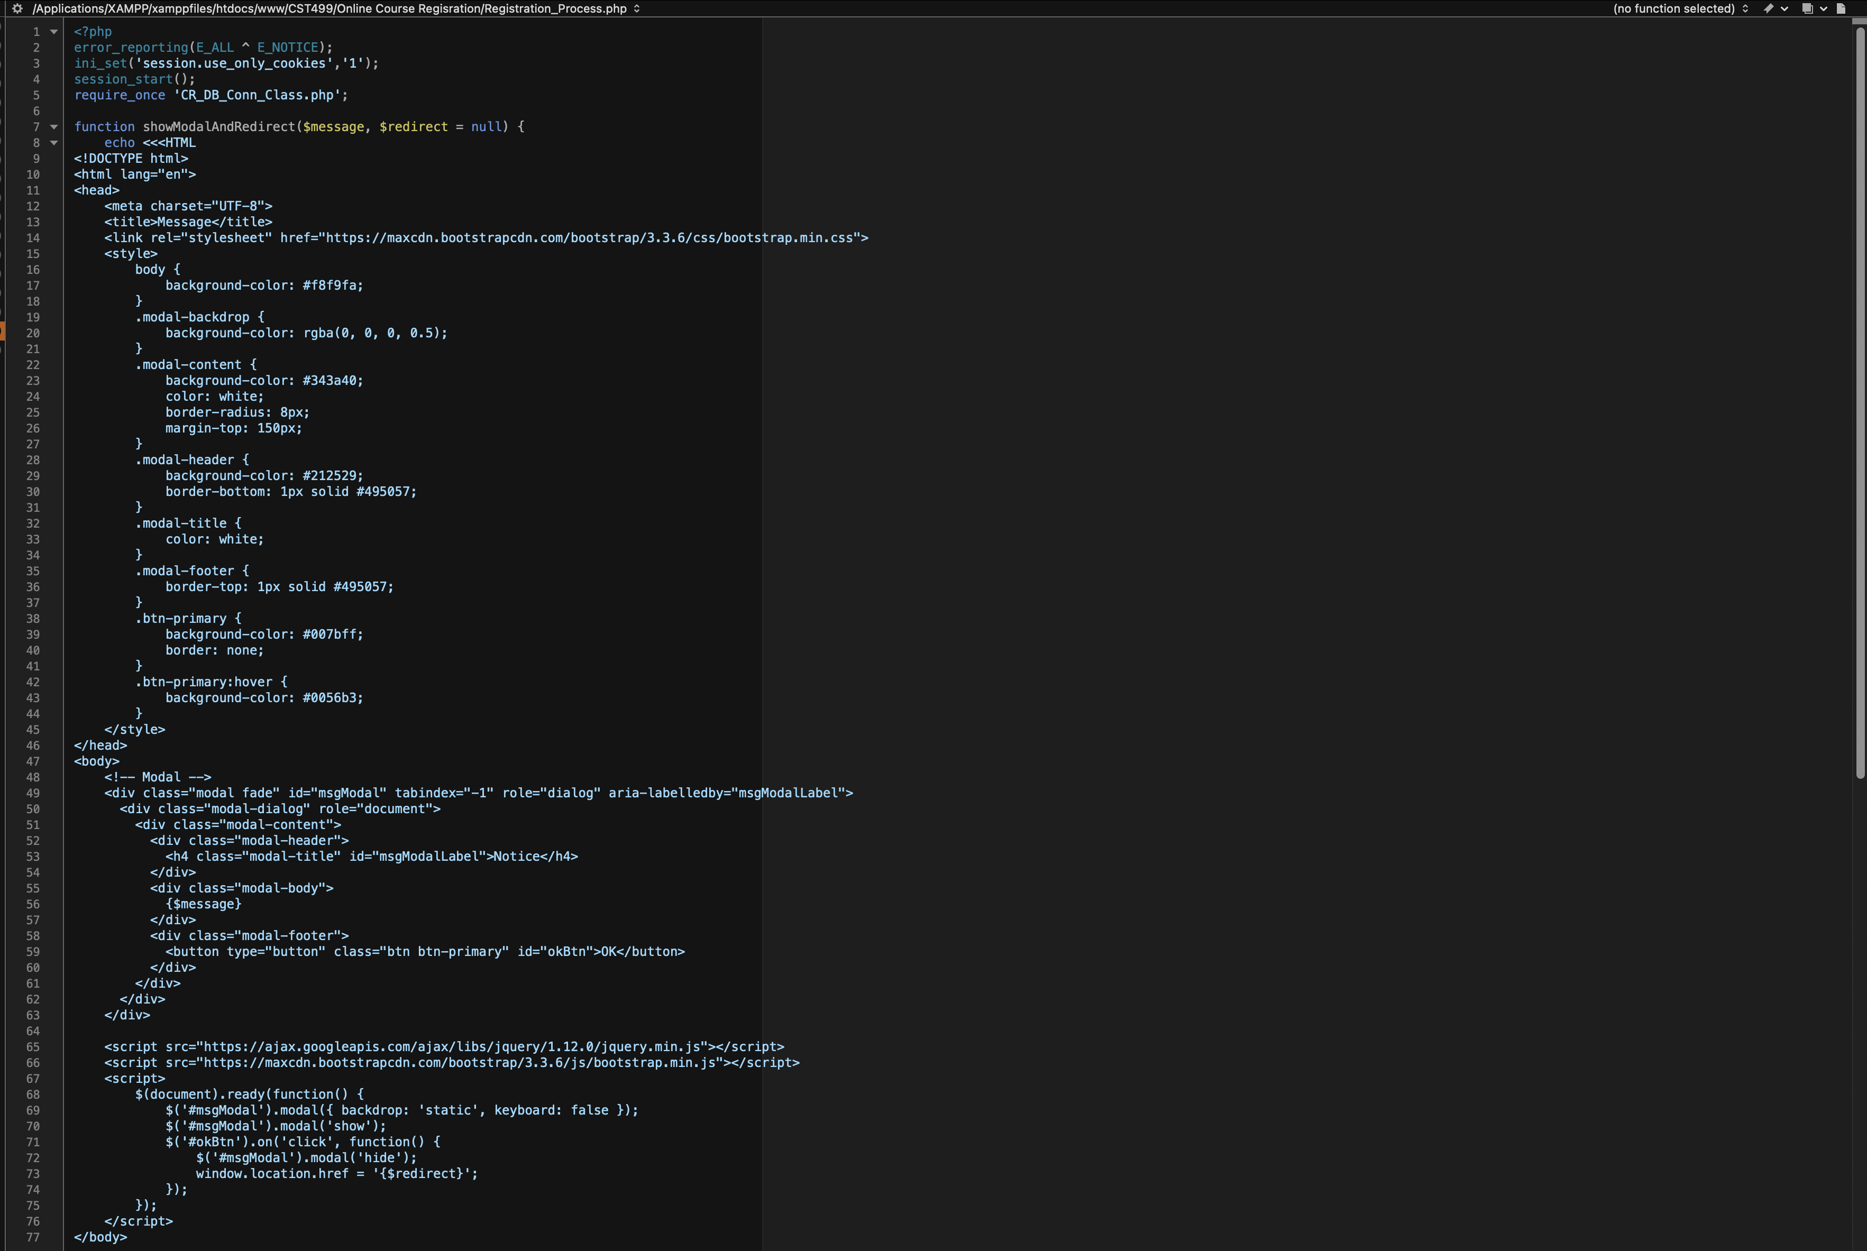

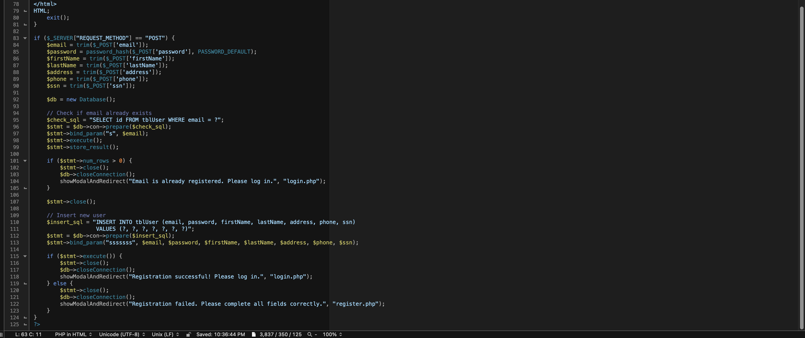

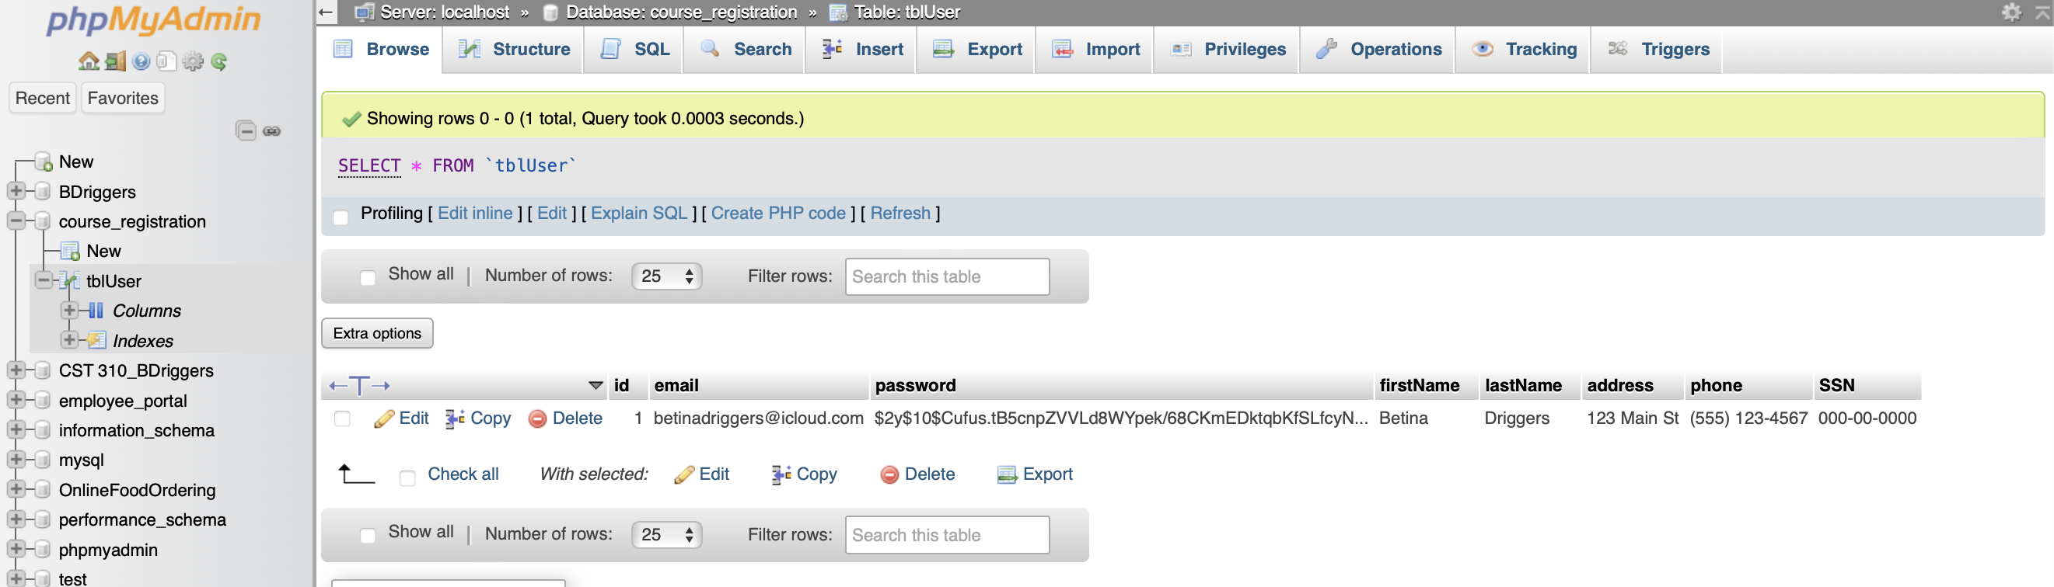**Online Course Registration Pages & Source Code**

**Home**:

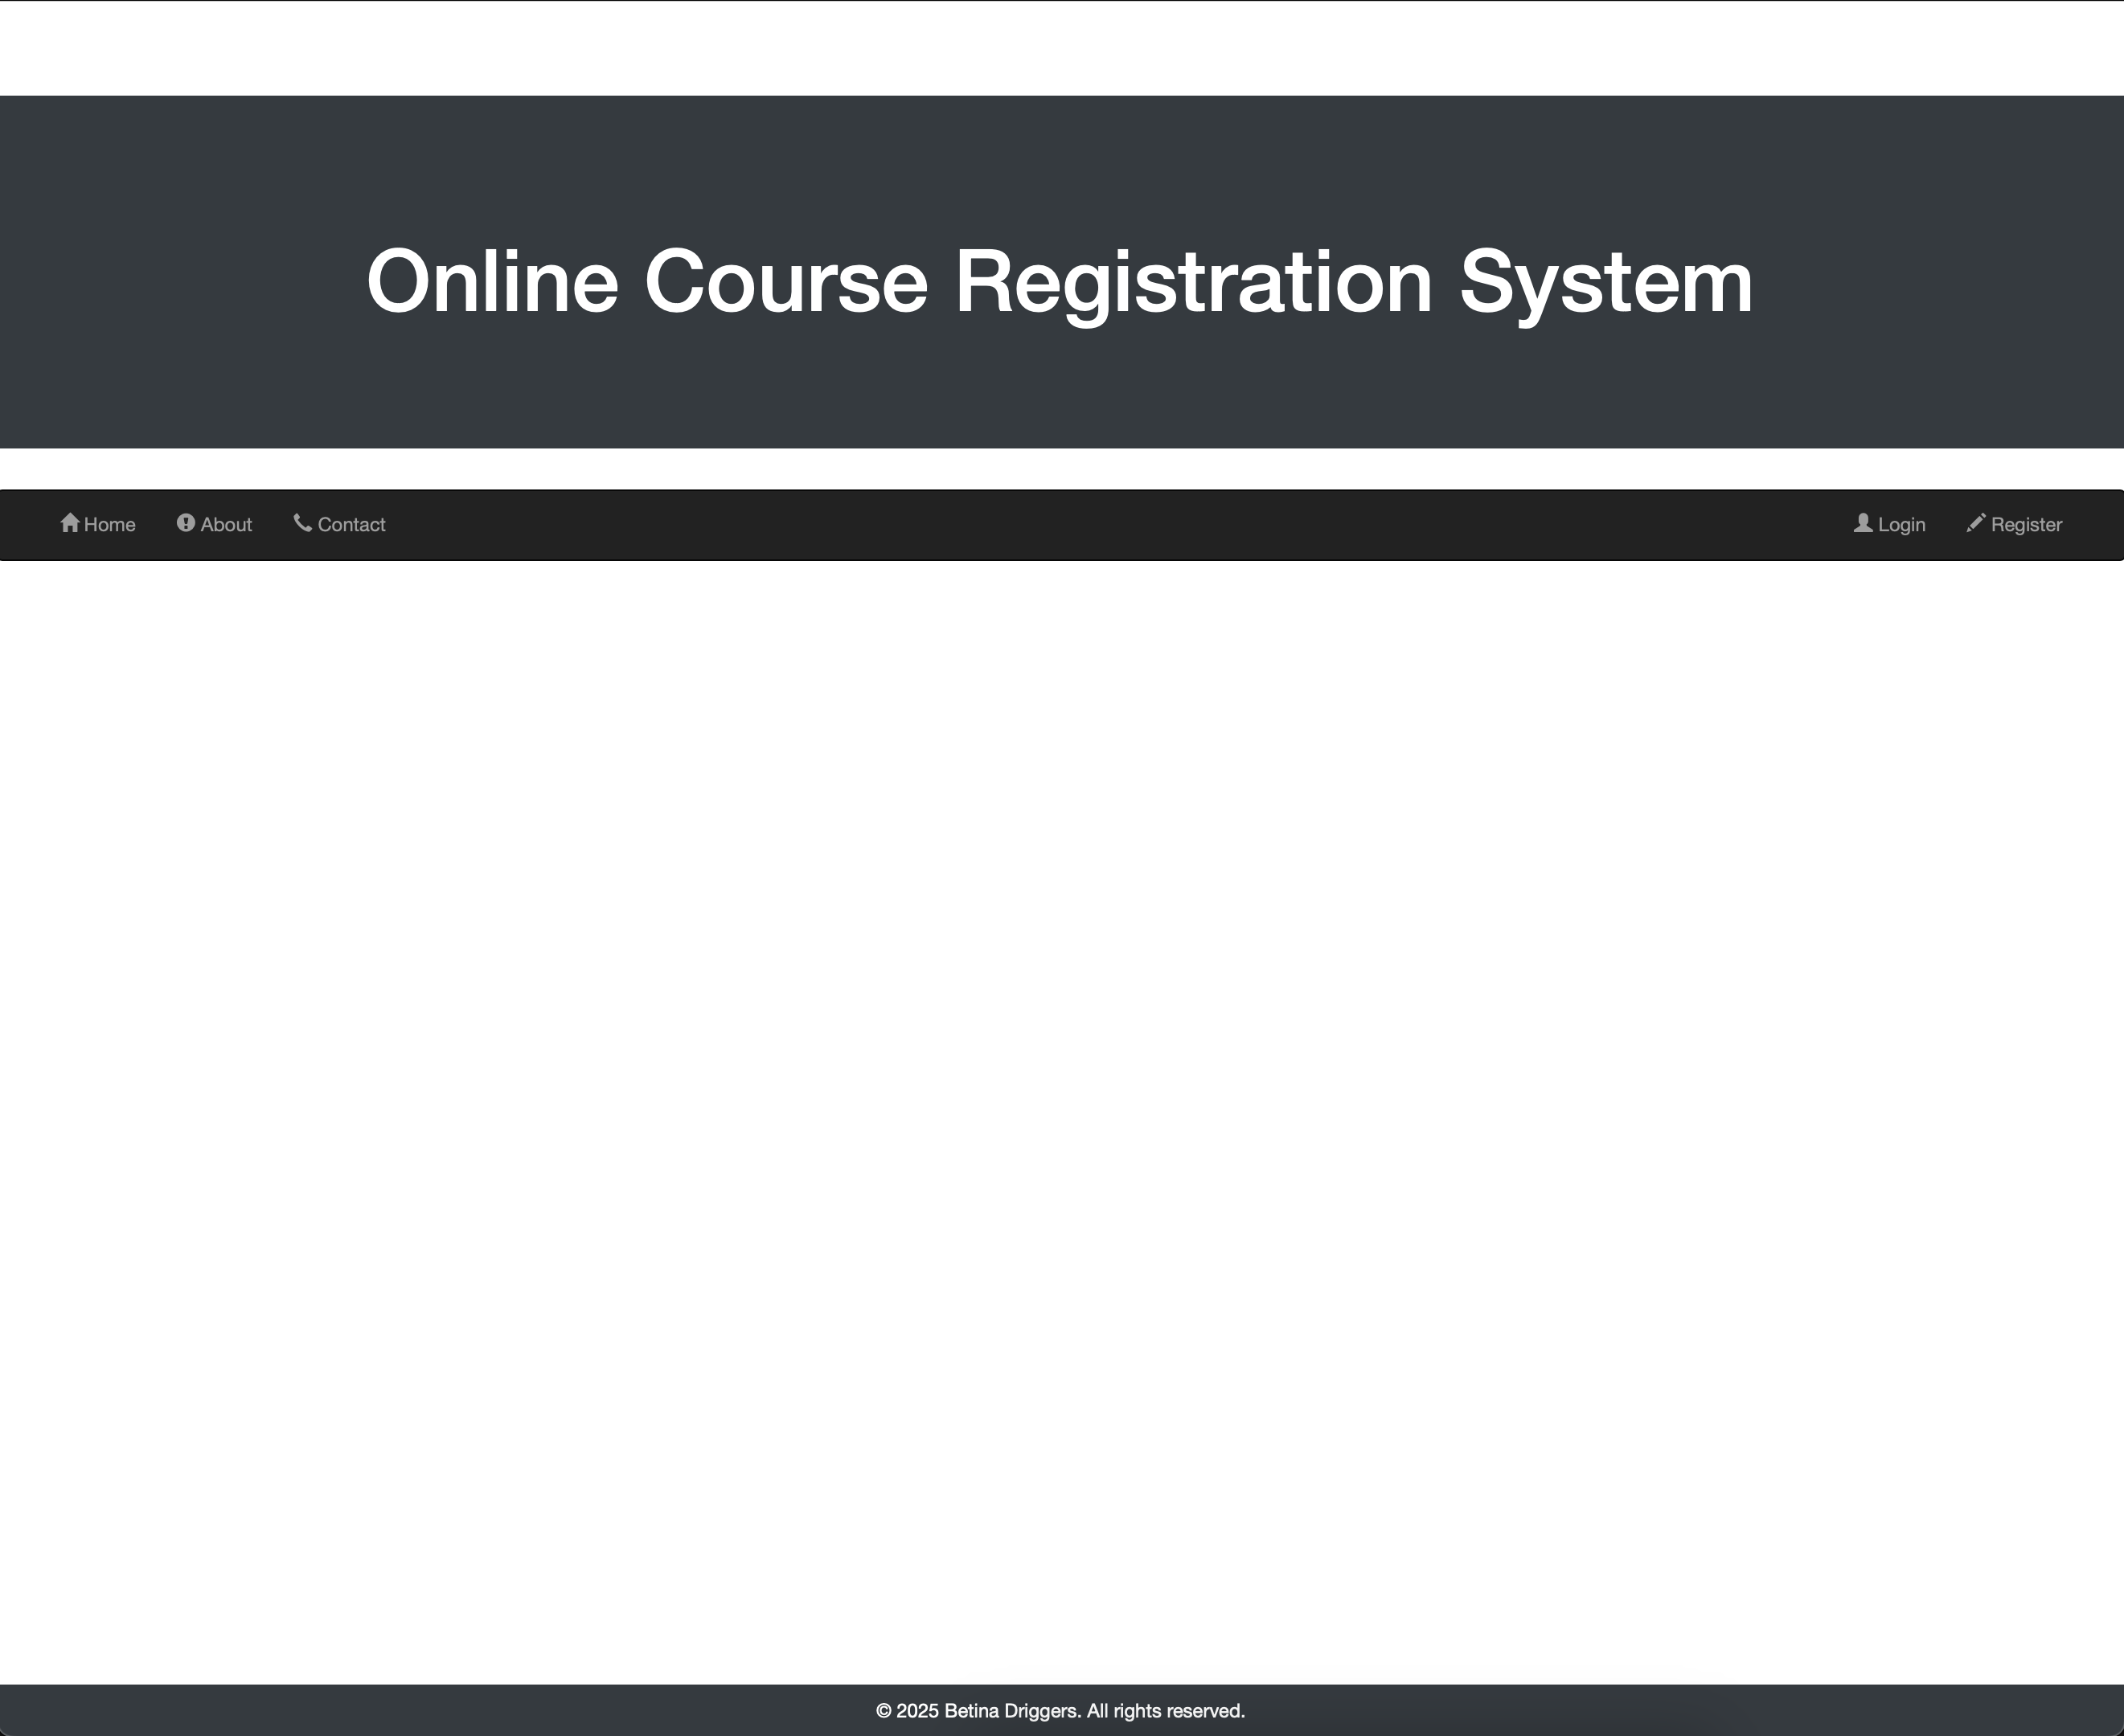

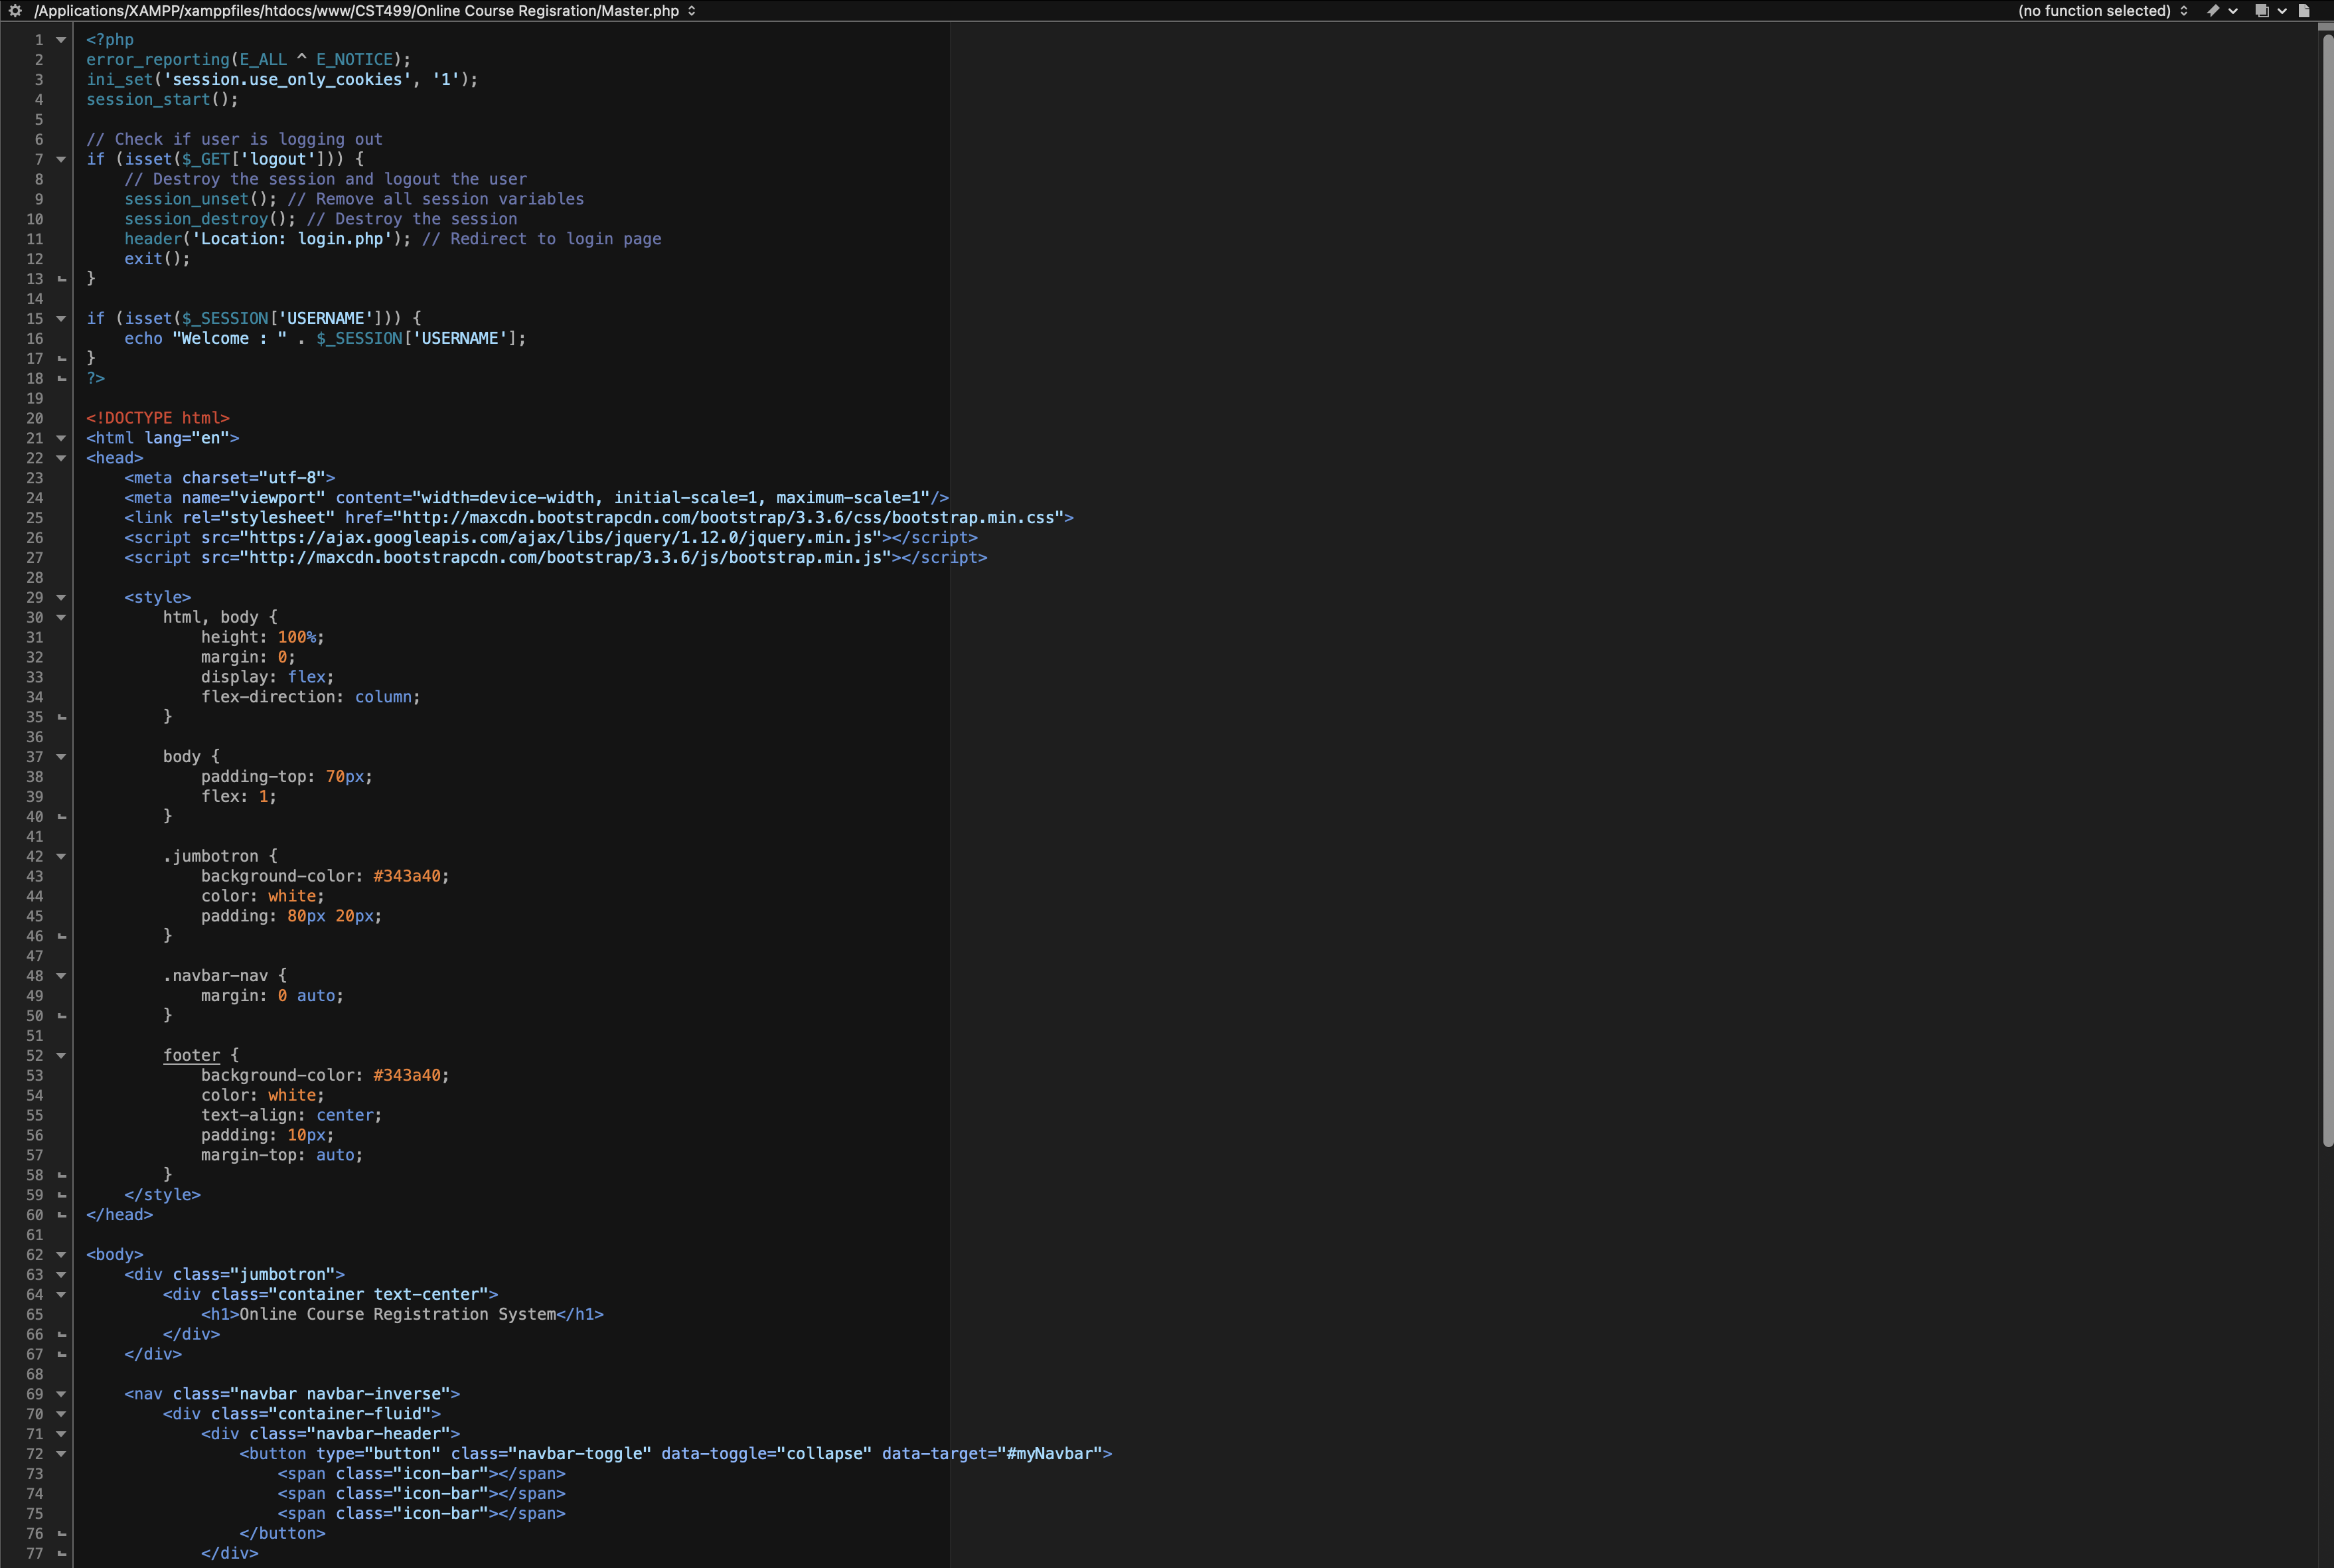  
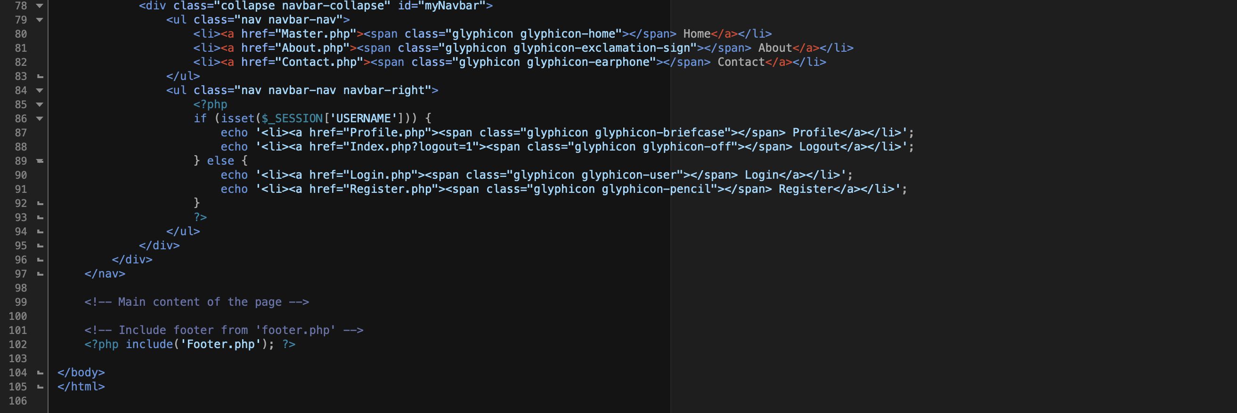

**Login**:

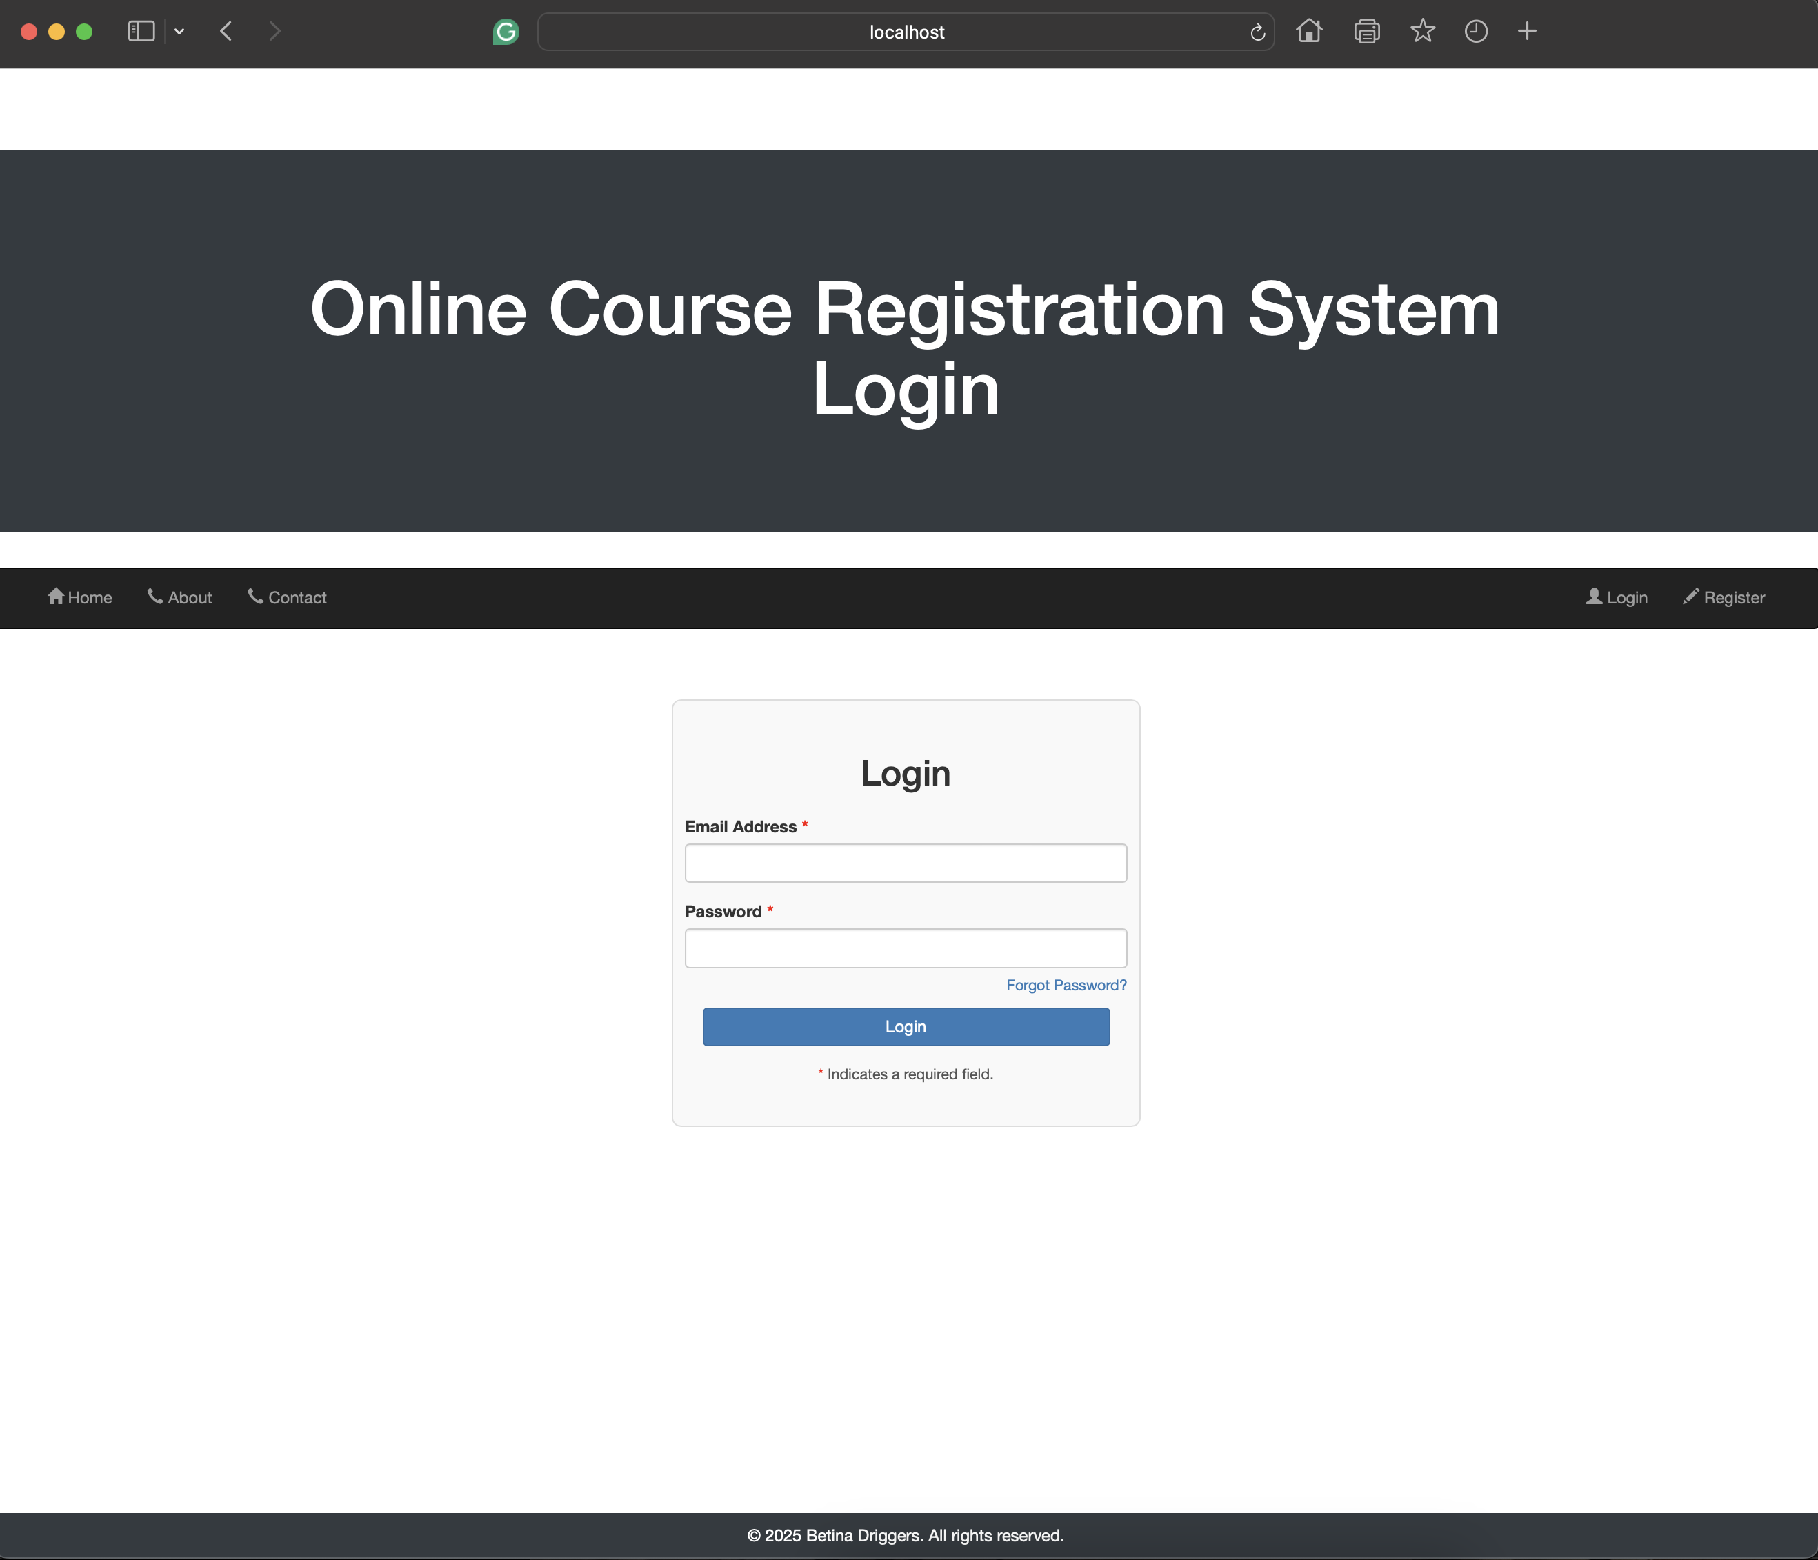

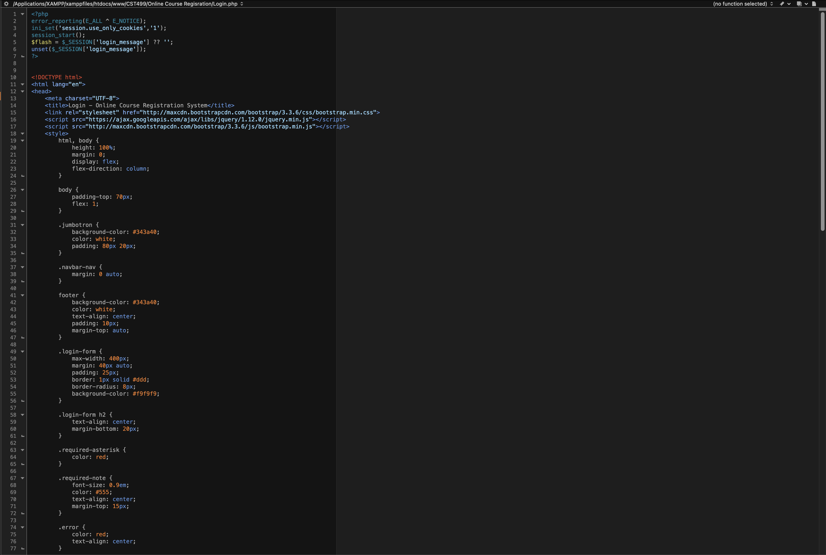 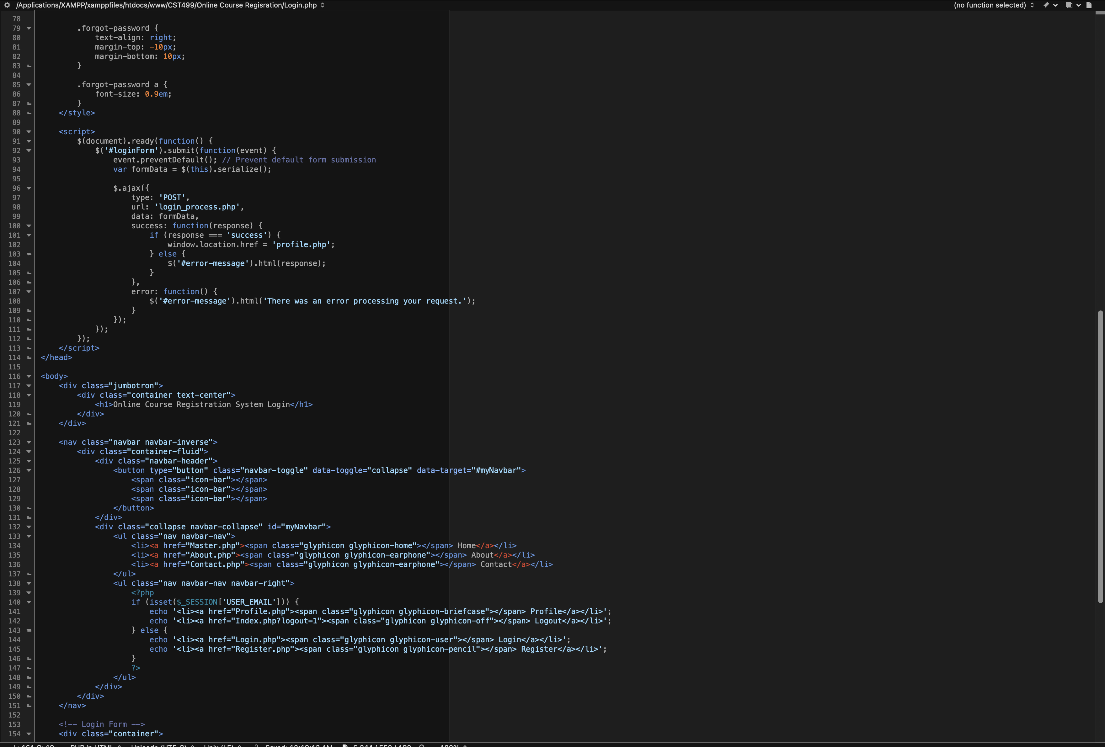 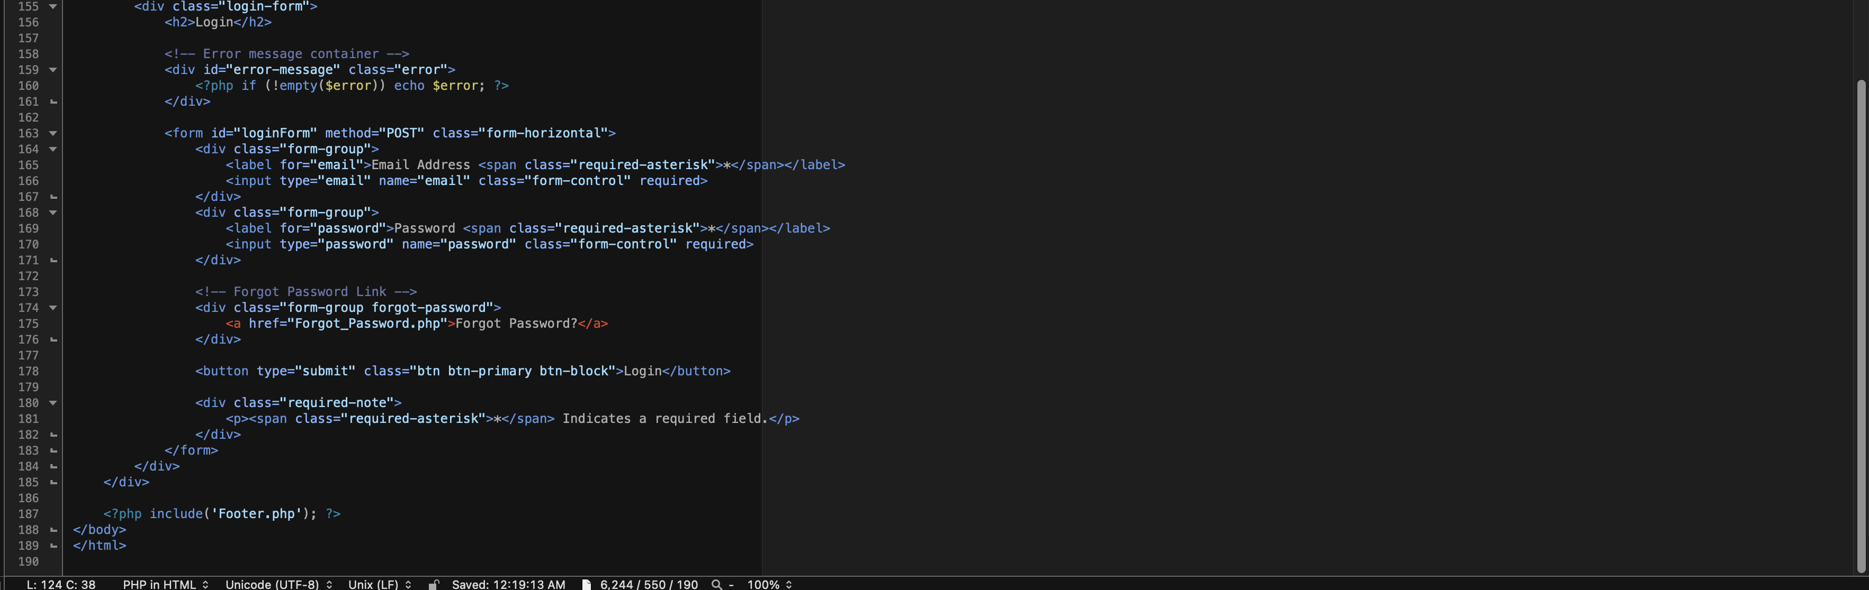

**References**

*Bootstrap*. (n.d.). GeeksforGeeks. <https://www.geeksforgeeks.org/bootstrap/>

*PHP OOP Constructor*. (n.d.). Www.w3schools.com. <https://www.w3schools.com/php/php_oop_constructor.asp>

*PHP: Password Hashing - Manual*. (n.d.). Www.php.net. <https://www.php.net/manual/en/faq.passwords.php> ‌

Tsui, F., Karam, O., & Bernal, B. (2018). [Essentials of software engineering](https://uagc.instructure.com/courses/150851/modules/items/7693353) (4th ed.). Jones & Bartlett Learning.

W3Schools. (2019). *SQL CREATE DATABASE Statement*. W3schools.com. <https://www.w3schools.com/sql/sql_create_db.asp>

*XAMPP FAQs for Mac OS X*. (2024). Apachefriends.org. <https://www.apachefriends.org/faq_osx.html>

‌